# Bad tempered Birds

## Design Doc

### Status:

The game is ready for a beta or an early release. The game has a few levels for the players to start with, along with two different birds for them to use. The entire gameplay loop has been implemented, and the game is can be played from the menu to the end without issues. Some things the game needs to add as development continues are as follows: The game needs additional birds to keep the different levels interesting and varied. The game will also benefit from different “pieces” with which to build the level. This could be a new material type to build the pig’s house with, or even a TNT block to explode when hit. Both of these give the game more variety, as the new material will force the player to approach the level in a different way, and the TNT block will give the player another target in the level, as opposed to just the pigs. The game also needs some quality of life changes. Some of these include, a settings menu to change things like sound volume or controls. The game has a basic UI when playing, with a score indicator and bomb counter on screen in the top left and right respectively (see below). This UI also has an onscreen button to mute the music. The UI will need to be expanded to include a settings menu and level selector. The level selector will let the player replay specific levels, which enhances replayabillity. The game also needs sound effects to better convey to the player what is occurring. This makes the game more readable and will make it easier to play.

This screenshot from the game shows the the UI that the player sees during the levels. Top left is the score counter, top right is the (remaining) bomb counter, and bottom right is the mute button.

### Elevator Statement:

The game is a casual angry birds style artillery game, but instead of using a catapult, the player has to launch the birds using bombs they can place anywhere. Each level has lots of ways to complete it, which gives each level replayability. In addition to this, there is also a high score system for completionists, which gived each level even more replayability.

### Concept:

The game is the very similar to Angry Birds, however, instead of launching the birds from a fixed catapult the player uses bombs to launch the birds. This gives the player more freedom in how they approach the level, as the bombs can be placed anywhere in the level, however it also makes it more difficult. The game becomes more difficult because it is harder to predict how the bombs will launch the bird compared to the catapult from the original games. The catapult also used a trail in the sky to show where the birds would go, but Bad tempered Birds players will need to use their intuitive understanding of physics to predict the flight of the birds.

### Genre:

The game is a casual mobile game, with taking from genres like the catapult/artillery game, and puzzle games. The artillery game inspiration is obvious as the game primarily consists of launching an object (bird) at a target structure. The puzzle aspect comes from how to actually hit the pig. The pig is protected by various structures and materials each with different properties. How to get past all of this is the puzzle. Both of these are also in the angry birds game, however, the artillery aspect of the game is different because the same bird is always used, instead of dying on impact. Furthermore, the player also must use bombs to launch the bird instead of the catapult or trebuchet, which is typically seen in artillery games.

### Target Audience:

The game has a wide target audience. The mobile games industry is massive, taking up 49% of the games industry revenue in 2023 at $90 billion. This means there is a large potential audience. This is capitalized on by making a casual game, that can appeal to lots of people. The game is a casual artillery game, with a child friendly art style and content. The target audience is largely the same as angry birds, however, it does deviate slightly, as Bad tempered Birds is slightly more difficult than angry birds. This is because it uses bombs instead of the typical catapult to launch the birds, so it is harder to finely control where the birds go.

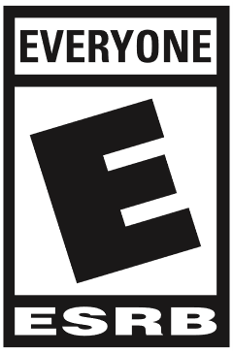A target ESRB rating would be as low as possible, preferably “E for everyone”, the aim of this game is to appeal to as wide an audience as possible. The best age rating available to achieve this is clearly the least restrictive “E for everyone” rating. The equivalent rating for PEGI would be the 3 years old rating, or the easier to achieve 7 years old rating.

The 7 year old rating for PEGI is much more likely for this game, as it does contain very mild violence against the pigs. Any violence in the game will get it the 7 year old rating. This basically forces the PEGI age rating target to be 7 years old.

### Key Moments:

The gameplay loop has a few key moments for every level. The first is when the level first starts, and the player is seeing the challenge for the first time. Here the player has to figure out and plan ahead what their plan is for this level. This part should be kept as clear as possible so as not to distract the player. The next key moment is when the player starts to destroy the pig’s building. This should also be kept relatively clear visually, so as not to overwhelm the player. This second key moment should have at least some visual shine to make it enjoyable to destroy the building and progress with the level. This is achieved through particle effects on the bomb and pieces, and camera shake when the bomb explodes. The final key moment is when the level is completed, and the end level menu appears. This menu shows the number of stars the player got and is the primary reward. This should be full of visual charm, such as bright particles or fireworks etc. It also should have a custom victory or loss sound later in development.

### Player Objectives:

The primary objective for the player is to kill all the pigs in the level. However, there is a secondary objective which is to finish the level with the highest score possible. This is achieved by destroying as much as possible, while using as little bombs as possible. This objective is represented by the stars system, whereupon completing each level, the player will be assigned zero to three stars depending on their success with the level. The levels are designed to first introduce the primary objective of killing the pigs. This is achieved by level one where the only thing in front of the bird is a singular pig (see below left). This intuitively guides the player towards killing the pig in this level and consequently all future ones. The secondary objective is only introduced once the player finishes the level (see below right). This means the player is typically focused on the primary objective of killing the pigs, with the secondary objective being available for players who want more of a challenge, without distracting everyone else.

### Progression:

There is only one form of progression in the game: the levels. The player progresses through each level one after the other, as they play. This is typically quite rewarding as the player can look at the level selector and see a real time tracking of their progress through each level, and sometimes how many stars they achieved. The game currently doesn’t have a level selector, but later in development it will be added. This is because without the level selector, the game lacks a lot of the reward from the progression through the levels. There is currently no way for the player to see how far they got, or how well they did on that level.

### User Interface:

The UI should use the same assets throughout the game, e.g. the same sprites for the buttons, the same text etc. This will add visual cohesion to the game and make the different UI elements looks like they are a part of the same game. It also increases the readability of the game. For example the buttons will always look the same, so the player will always know what a button looks like.

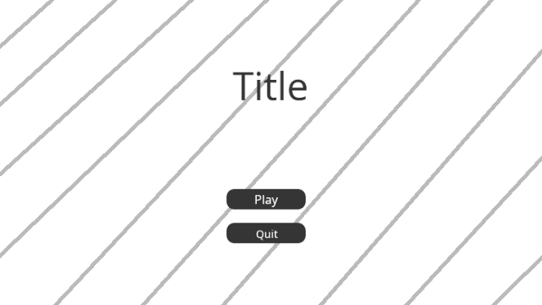The first thing the player will see is the main menu. This should have two buttons: Start and Quit. These should be under the title, with a generic contrasting background behind them. This background will wiggle side to side to keep the background visually interesting. The buttons should be centred and rectangular. The buttons will have contrasting text on them, explaining their purpose. The top button will play the first level, the bottom button will quit out of the application.

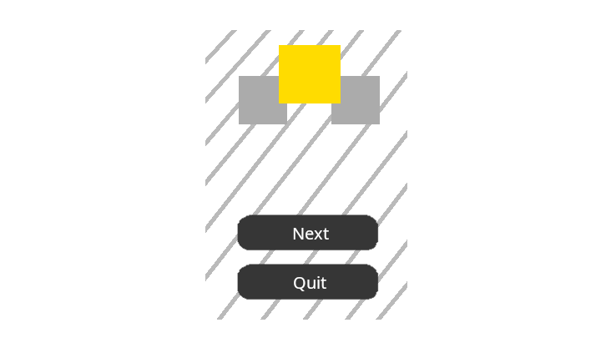

The menu that appears when the player completes a level should be a vertical rectangle, with rounded corners. This rectangle should have a solid fill contrasting background and take up about 80-90% of the screen (vertically). The menu will have two centred buttons, very similar to the main menu. The buttons will have contrasting text on them. The top button will play the next level, the bottom button will quit to the main menu. At the top of the menu will be three stars that are grey when not achieved, and gold when achieved. This will be controlled by the script and come from the score achieved in the level.

### Tools:

The game is made almost entirely within the Unity Engine. The only other tools used are GIMP for creating sprites, Visual Studio for creating scripts, and Git for version control. The Unity Engine handles the physics, rendering, input, scene management, window handling, asset loading, etc. All of these systems are designed to work in harmony with each other. This helps streamline development, as the developers don’t need a lot of interoperability between toolchains. This is important as there can often be issues trying to get several toolchains to work together, which slows down development and makes it harder to change anything. Furthermore, the other tools used use formats that Unity can handle directly. This again simplifies the toolchains and helps interoperability.

To actually create levels, the developer should use the “SampleScene” as a base. It contains all the required elements for a level, and a basic building as an example. When adding pieces, they need to be assigned a reference to the GameManager in the inspector. Once all the pieces are placed, the pigs should be placed next. For each pig placed in the scene, the maxPigs variable on the GameManager should be incremented. Finally, maxScore, the score required for 3 stars, should be set on GameManager to complete the functionality. When each scene is added to the build index, the maxSceneIndex constant should be incremented on EndLevelScript. If all of this is done, the game should be able to flow from one state to the next until all the levels are completed.

To create a new piece type, the developer should copy one of the existing prefabs for both the piece and the break particles. The piece prefab will have a Piece script, which can be used to vary the behaviour of different materials. The main things the developer should look at when changing values is the breakThreshold, which controls how fast an object must be moving to break the piece, and the mass (on the rigidbody not the script) which changes how easy it is to move the piece by hitting it.

### Localization:

The game is not very text heavy. All the text is in the UI, primarily the buttons and title. The game is in English, but it should be trivial to localize the game. In total there are 4 buttons that are reused, the “score” text, and the title. To actually localize the game there are lots of options available, the most obvious and easiest one is Unity’s localization package. This lets developers localize text, strings, and other assets such as PNGs. This would be used to localize all the text in the game.